Rectifying Plan Images
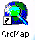
- Locate the ArcMap icon on your desktop and double click it.

- Once the application is open, find the “globe” on the top menu bar and click it. This will load up the standard OP Base Layers. 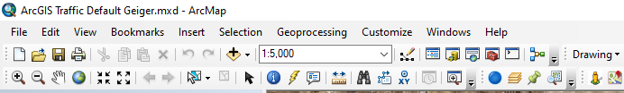

- Click on the “Add Layers” button in the top menu bar.

- It will bring up all the layers that are available as shown below. Click on “Air Photos” on the left hand side. It will load up all the available aerial photograph layers on the right side. You should generally select the most recent “orthophoto” aerial photo. Add the appropriate layer and click “Close”
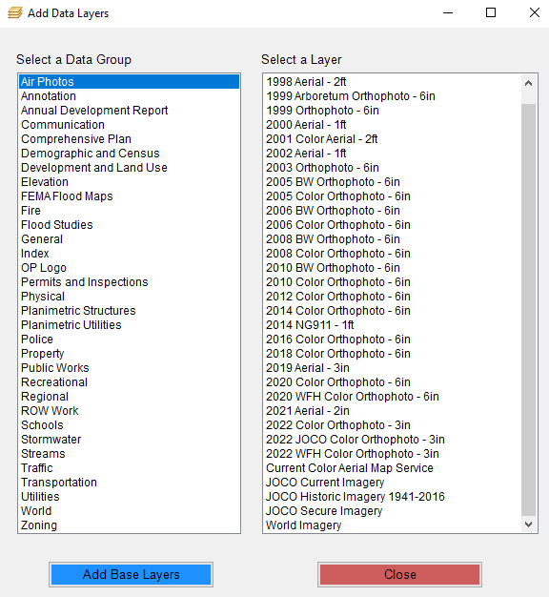
Click after selecting layer
- Using the magnifying glass “Zoom In” feature on the tool bar, zoom into the area that you want to insert a rectified plan sheet.

- Click on “Windows” in the upper menu and select “Viewer”. This will open a small viewer screen on your desktop.
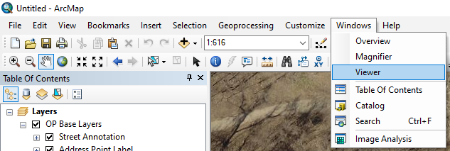

- Locate the TIF image or PDF file you want to rectify and make a copy on your desktop or wherever you will remember where you located it.

- Return to ArcMap. Click on “Customize” in the top menu bar and then click “Toolbars”. Make sure that the box next to “Georeferencing” and “Data Frame Tools” is checked. Then you can close this box.

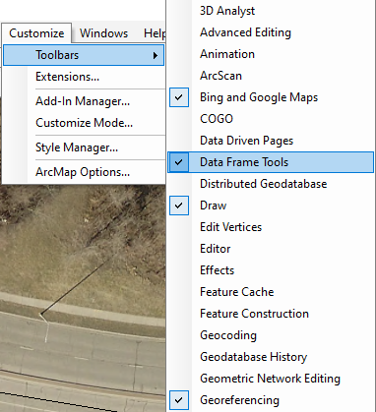
Check the “Georeferencing” check box
Check the “Data Frame Tools” box

- This will create two sub-menus, as shown below, that you can then “dock” in the top menu bar by clicking and dragging it.
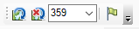

- Set the rotation angle on the “Data Frame Tool” to “0”. The default is 358 so everything appears vertical and horizontal. However, the process will not function unless you reset the angle to 0.

- Click on the ”Add Data” tool and browse to the location you saved the .TIF file you want to rectify. Highlight the file name and select “Add”.
1. “Add Data”
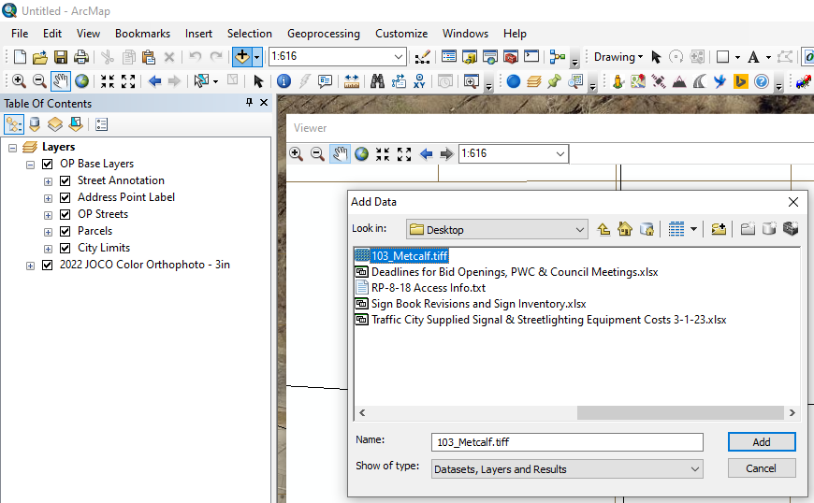
2. “Select File Location”
3. “Add”

If you are using a multi-page TIF image, another screen may come up as shown below. The sheet desired in this case is the plan sheet, which is the second sheet. Therefore, you would select subdataset 1 and click “OK”

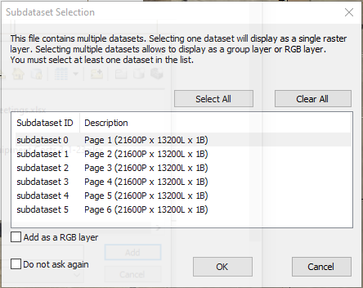
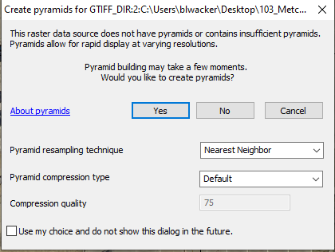

Another screen may come up asking if you want to “Build Pyramids”. If so, click “YES”. You may get a warning that pops up saying “Failed to build pyramids”. Click “OK”. Another box may pop us saying “Unknown Spatial Reference”. Click “OK”. This loads the sheet as a layer in the right hand “Layer” column.
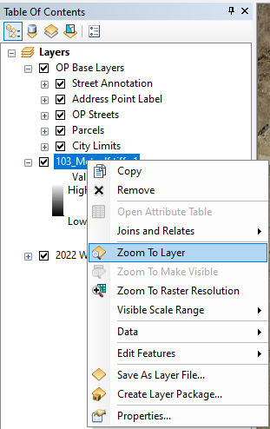
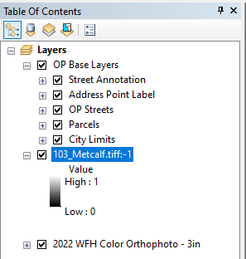

Loaded TIF Image

- Find the newly added layer in the right hand “Layer” column and right mouse click on it. Select “Zoom to Layer”. This will take you to the location in space where the layer was brought in at.

- Find the “Layer” identification box on the tool bar and make sure it shows the plan sheet name that you want to insert. If not, use the down arrow key at the right end of the box and select the appropriate file.
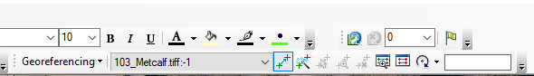
“Layer” box

- The process of rectifying a drawing to the aerial in ArcMap requires that you select two points that are readily identifiable on both the plan sheet and the ArcMap application aerial. Make sure the two points are located as far apart on the sheet as possible. You will essentially be stretching the plan sheet across the two selected points. The use of property corners or surveyed point on an existing curb may be the most accurate if available. You can compare the plan view and the aerial view by using the view window that was opened earlier. You can zoom in and out of either view without affecting the procedure.

- Locate the “Add Control Points” on the tool bar and click on it. Pick the first common point from the plan sheet. Go to the other view and pick the same common point on the ArcMap aerial view. This will bring in a small scale plan view anchored at the first point you selected as shown below.
“Add Control Points”

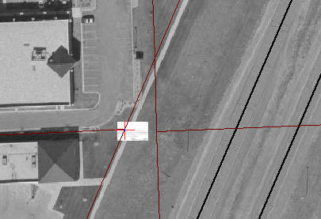

Small plan sheet inserted and anchored at first control point

- Zoom back to the plan sheet layer again by right clicking on the layer name in the ArcMap “Layers” box. Zoom in to the area near the second control point location. Select the “Add Control Points” button again and select the second control point from the plan sheet view. ALWAYS SELECT FROM THE PLAN SHEET VIEW FIRST THEN THE ARCMAP AERIAL VIEW. Use the other aerial view again and zoom to the ArcMap aerial view. Select the common second control point from the ArcMap aerial view. This will stretch the plan sheet to full size in real space.

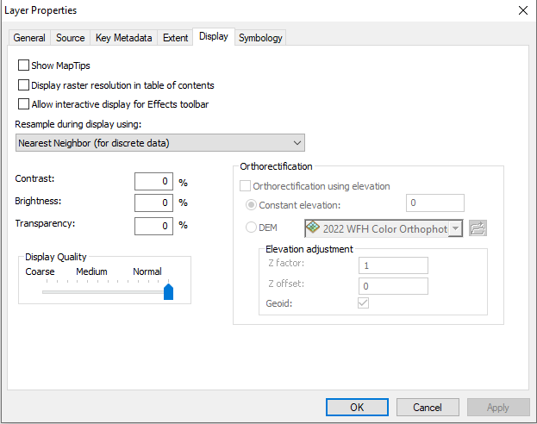
- On the “Layers” menu, double click on the layer for the plan sheet. Select the “Display” tab and set the Transparency to 50%. This will allow you to see through the plan sheet to see if the rest of the visible lines match with the aerial lines.
Set Transparency to 50%
“Display Tab”

- Find the “Georeferencing” tool in the menu and click the down arrow next to it. Select “Rectify….”.
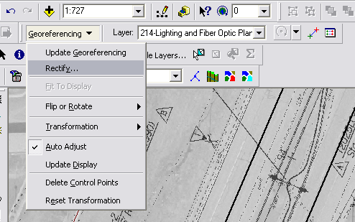

- When the “Save As” dialogue box pops up, type “rectified” in front of the filename and change the file format to “TIF” and click “Save”. This will save the rectified plan sheet in the same place you saved the original .TIF file on your local hard drive with the same file name except it will have “rectified” in front of it. Click “Save”

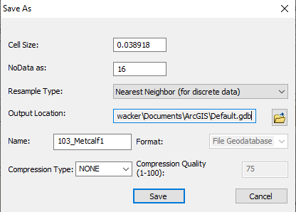
Type “Rectified” in front of file name

- Copy all the rectified plan files (all extensions) from your personal folder back to the K:\Library\Plans\images\”Your Project Number”\”Desired Plan Sheet”

- Add the points (signs, light poles, junction boxes, etc.) on the plan sheet just as you would directly on the aerial view.

- To remove the rectified plan sheet, Click on “View” on the main menu and select “Remove Rectified Plan Page”.

